**Assignment -3**

Cloud Object Storage and Watson Assistant

|  |  |
| --- | --- |
| Assignment Date | 18 Nov 2022 |
| Student Name | Sakthivel M |
| Team ID | PNT2022TMID30061 |
| Maximum Marks | 2 Marks |

**Question-1:**

Create a Bucket in IBM object storage

**Solution:**

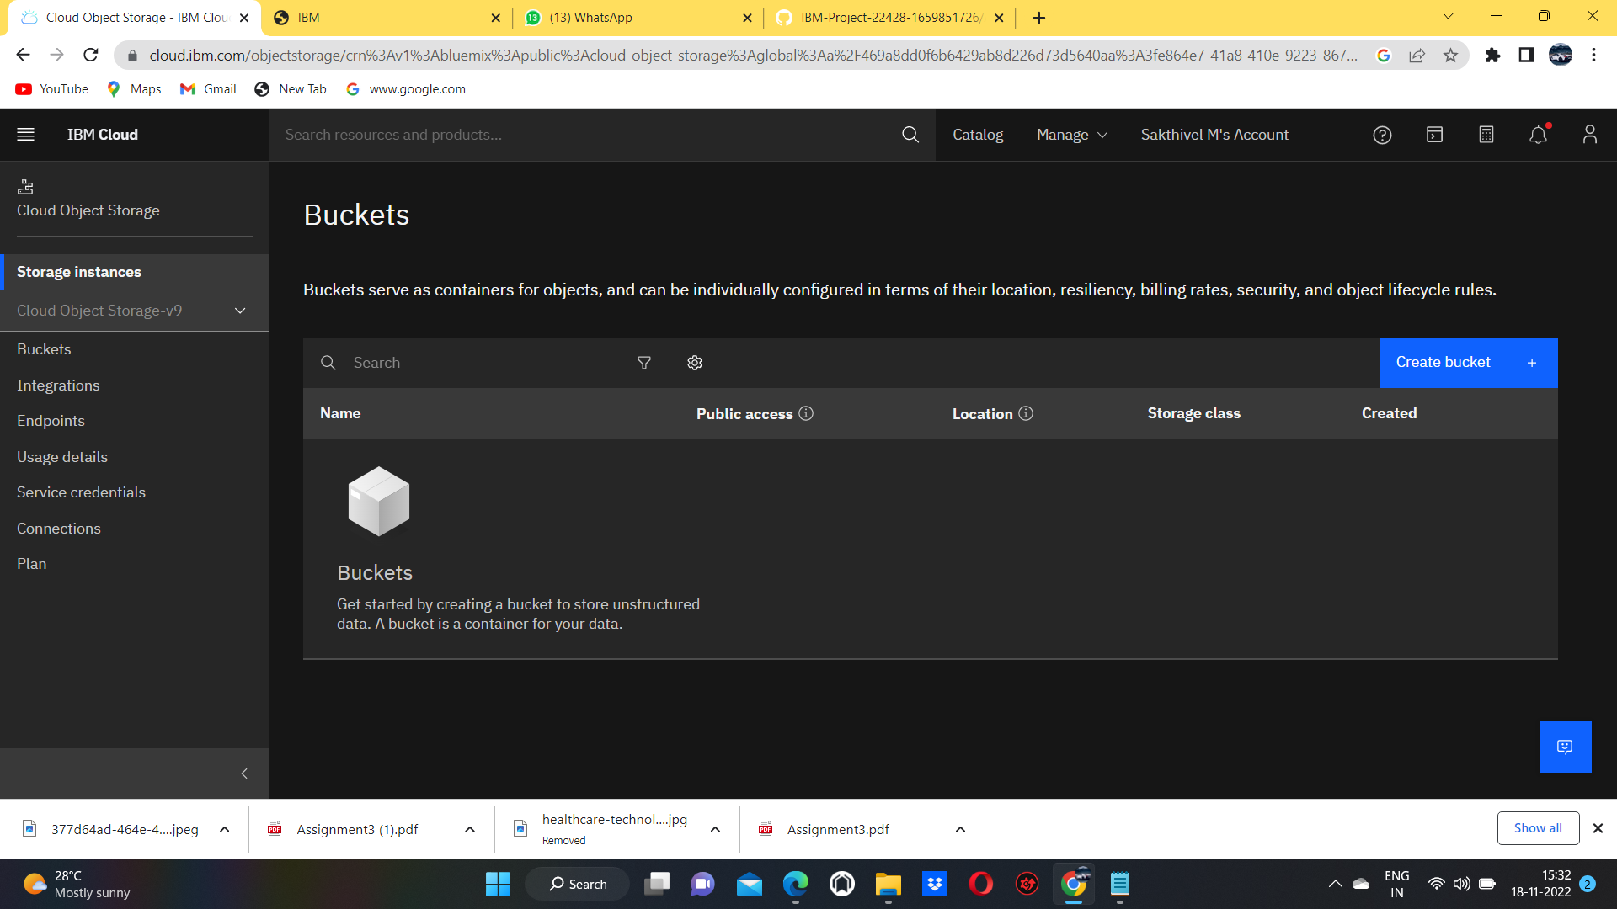

**Question-2:**

Upload an 5 images to ibm object storage and make it public. write html code to displaying all the 5 images.

**Solution:**

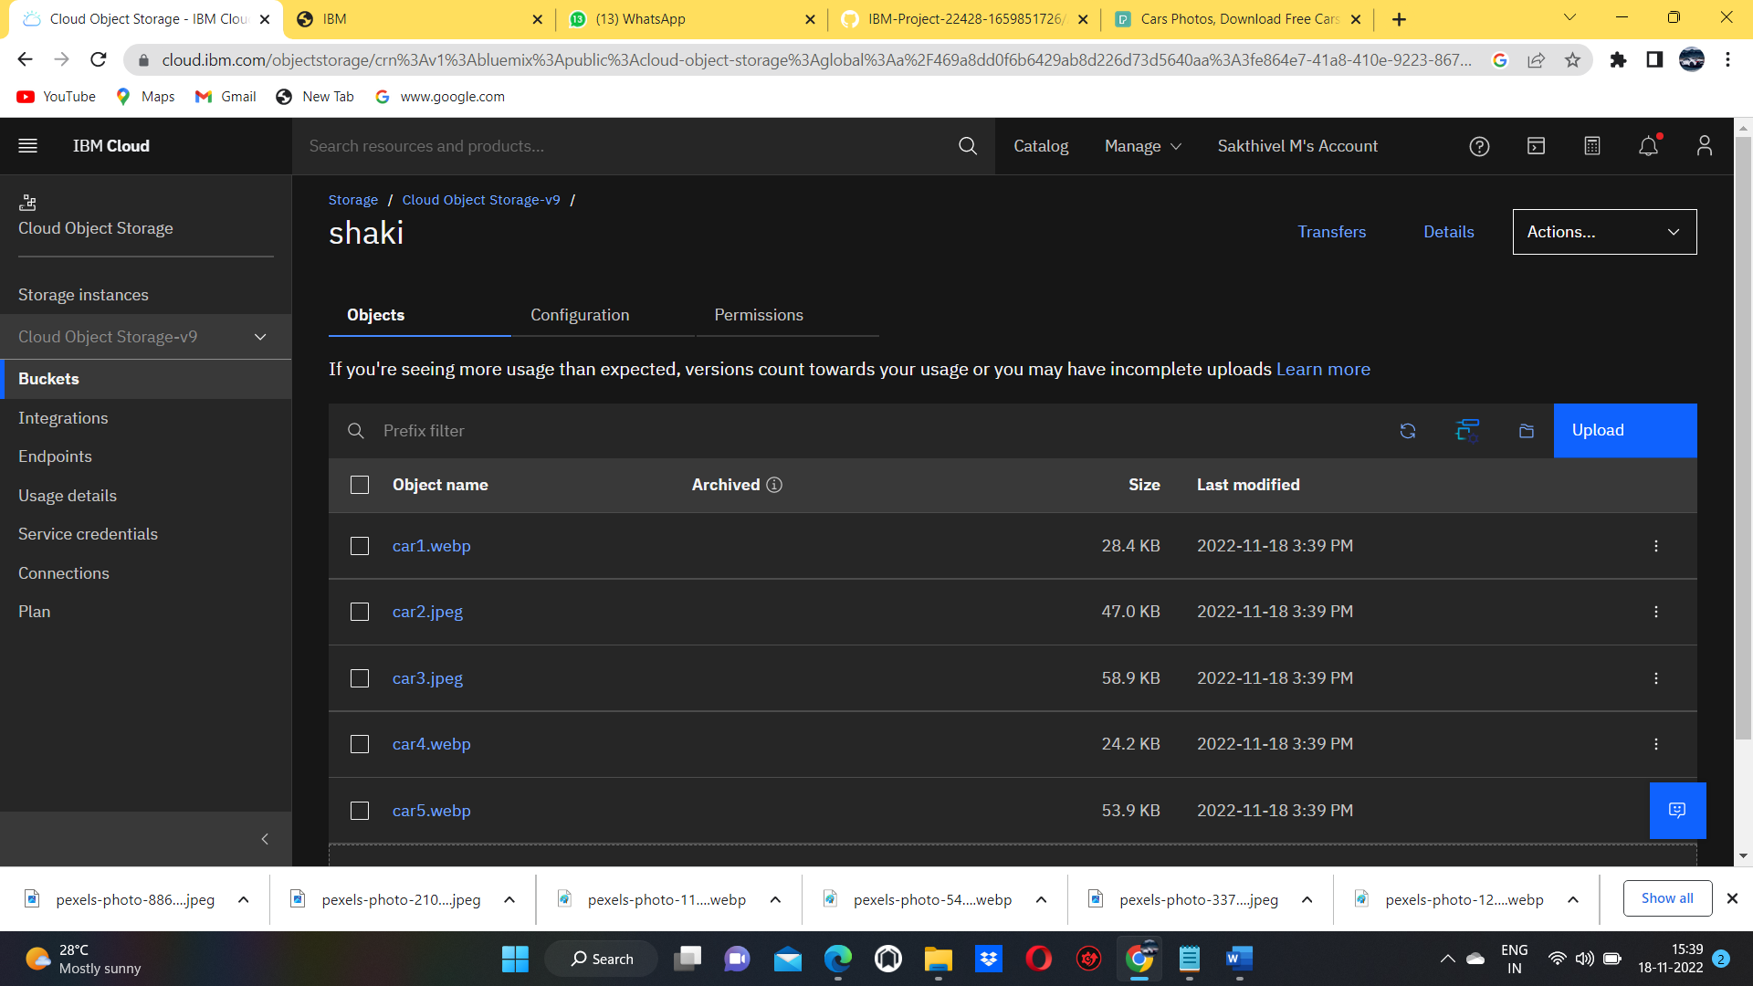

**HTML CODE:**

<!DOCTYPE html>

<title>Assignment</title>

<head> <style> img{ display: block; margin-left: auto; margin-right: auto; border: aqua; width: 50%;

}

Body{

style="border:rgb(15, 15, 15); border-width:5px;

border-style:double;text-align: center;font-family: Arial, Helvetica, sans-serif; background-color:green"

}

</style>

</head>

<body style="background-color: cyan;">

<h1>Nutrition Assistant</h1>

<img src="https://s3.jp-tok.cloud-object-storage.appdomain.cloud/shaki/car1.webp" >

<br>

<img src=" https://s3.jp-tok.cloud-object-storage.appdomain.cloud/shaki/car2.jpeg" >

<br>

<img src="https://s3.jp-tok.cloud-object-storage.appdomain.cloud/shaki/car3.jpeg" >

<br>

<img src="https://s3.jp-tok.cloud-object-storage.appdomain.cloud/shaki/car4.webp" >

<br>

<img src="https://s3.jp-tok.cloud-object-storage.appdomain.cloud/shaki/car5.webp" >

</body>

</html>

**Question-3:**

Upload a css page to the object storage and use the same page in your HTML code.

**Solution:**

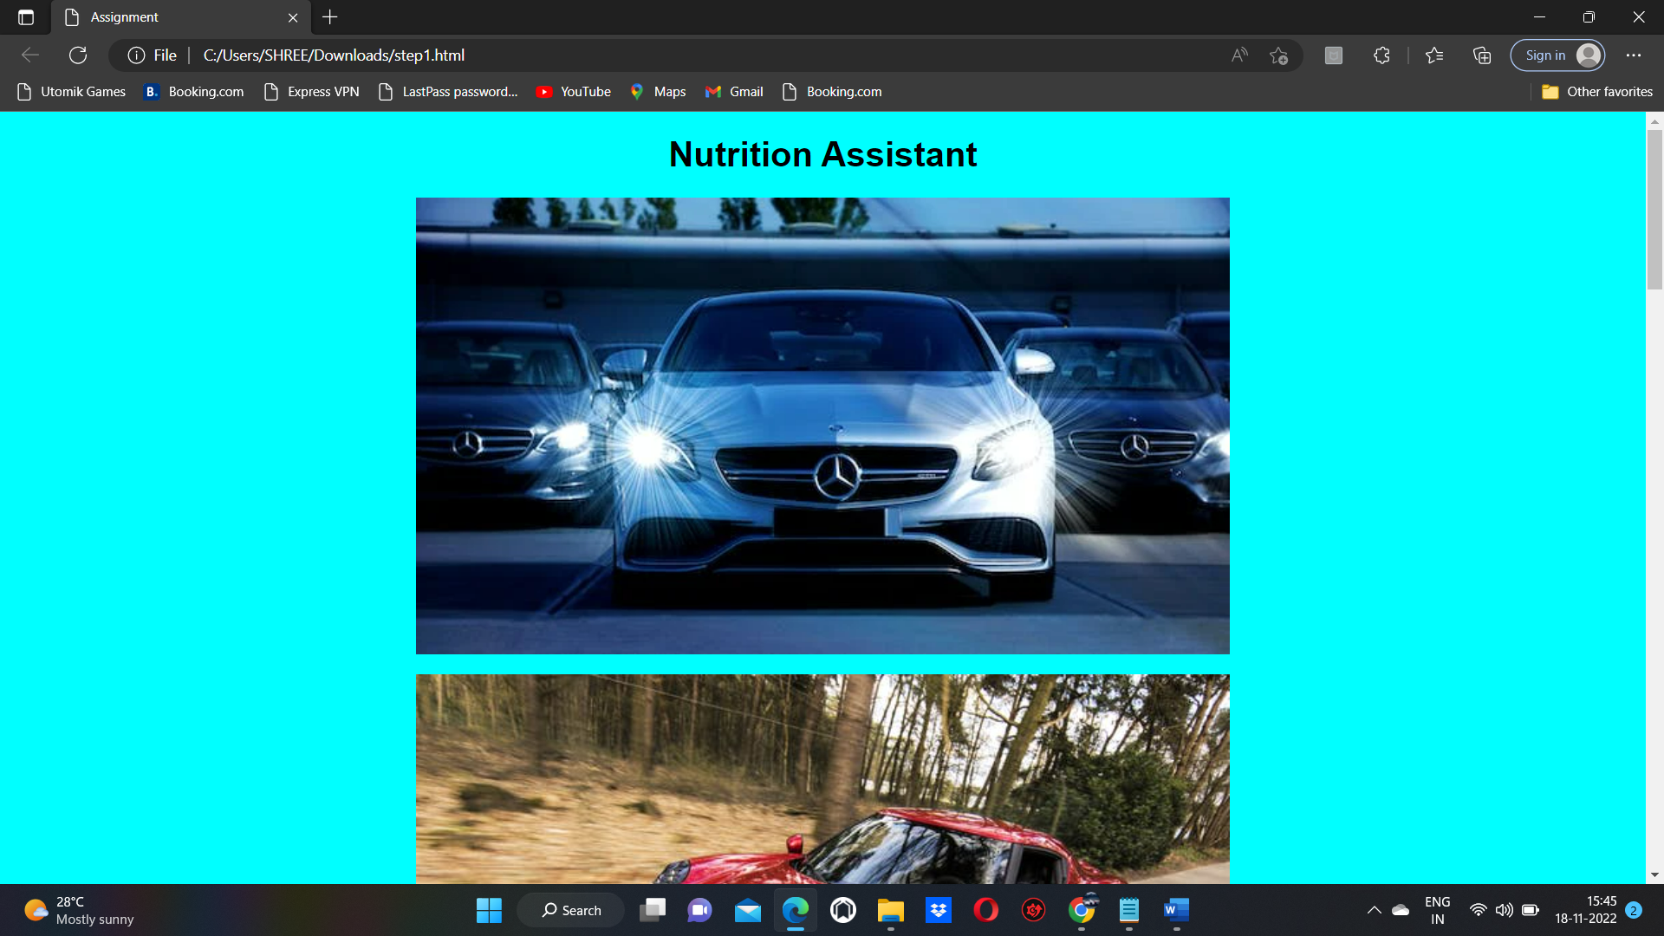

**Question-4:**

Design a chatbot using IBM Watson assistant for hospital. Ex: User comes with query to know the branches for that hospital in your city. Submit the web URL of that chat bot as a assignment.

**Solution:**

**URL:**

https://web-chat.global.assistant.watson.appdomain.cloud/preview.html?backgroundImageURL=https%3A%2F%2Fau-syd.assistant.watson.cloud.ibm.com%2Fpublic%2Fimages%2Fupx-1dd76cbe-0ba3-4e7e-9a1a-e01d940b15f1%3A%3A4e52af6d-075d-4e0b-8094-a196968163b6&integrationID=5c0346e6-f5e7-4833-8699-e92954c40b68&region=au-syd&serviceInstanceID=1dd76cbe-0ba3-4e7e-9a1a-e01d940b15f1

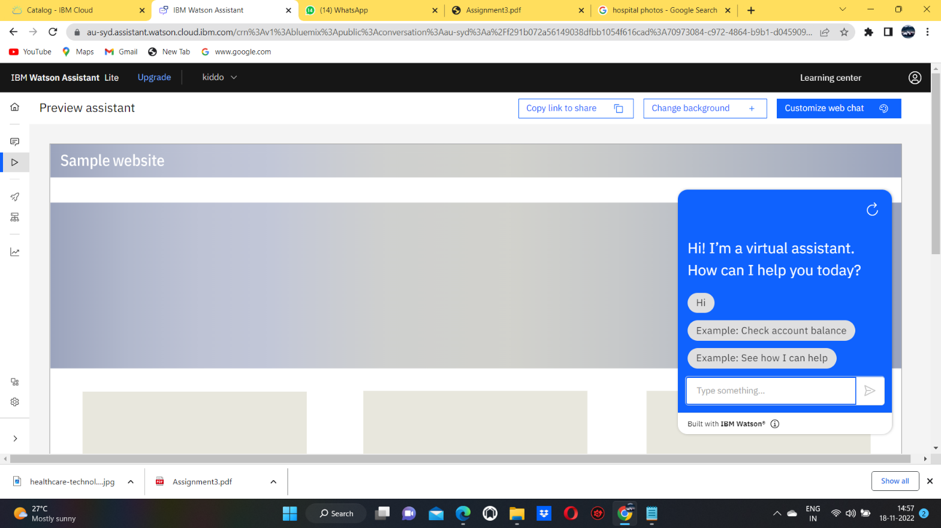

**Question-5:**

Create Watson assistant service with 10 steps and use 3 conditions in it. Load that script in HTML page .

**Solution:**

<!DOCTYPE html>

<html lang="en">

<head>

<meta charset="UTF-8">

<meta http-equiv="X-UA-Compatible" content="IE=edge">

<meta name="viewport" content="width=device-width, initial-scale=1.0"> <title>Hospital</title>

<style> body { font-family: Verdana, Geneva, Tahoma, sans-serif; background-color:rgb(241, 120, 128); font-size: 1.7rem; color: rgb(1, 22, 74);

} a { color: rgb(25, 52, 0); text-decoration: none;

}

h1{

text-shadow: 2px 2px 8px #C01986; background-image:"C:\Users\G RENUKA DEVI\OneDrive\Desktop\healthcare-technology-doctor-using-digital-tablet-iconmedical-network-hospital-background-162019727.jpg"; background-repeat:no-repeat;

background-size: cover;

}

a:hover {

color: rgb(0, 29, 1); padding: 5px 20px;

background-color: #C8D40C; border-radius: 5px;

transition: .5s ease-in-out;

}

</style>

</head>

<body>

<center><br><br><br>

<h1>Shaki car servies</h1><br>

<a

href="https://web-chat.global.assistant.watson.appdomain.cloud/preview.html?backgroundImageURL=https%3A%2F%2Fau-syd.assistant.watson.cloud.ibm.com%2Fpublic%2Fimages%2Fupx-1dd76cbe-0ba3-4e7e-9a1a-e01d940b15f1%3A%3A4e52af6d-075d-4e0b-8094-a196968163b6&integrationID=5c0346e6-f5e7-4833-8699-e92954c40b68&region=au-syd&serviceInstanceID=1dd76cbe-0ba3-4e7e-9a1a-e01d940b15f1"> Click here for assistance </a>

<img src="C:\Users\SHREE\Pictures\car shead.jpeg">

</center> <script> window.watsonAssistantChatOptions = { integrationID: "c59bbca4-33e8-44fe-8333-35cd5f3a645c", // The ID of this integration. region: "au-syd", // The region your integration is hosted in. serviceInstanceID: "cbc8164a-0e58-430e-9697-b4267c2d2150", // The ID of your service instance.

onLoad: function(instance) { instance.render(); }

};

setTimeout(function(){

const t=document.createElement('script');

t.src="https://web-chat.global.assistant.watson.appdomain.cloud/versions/" +

(window.watsonAssistantChatOptions.clientVersion || 'latest') + "/WatsonAssistantChatEntry.js"; document.head.appendChild(t);

});

<script>

window.watsonAssistantChatOptions = {

integrationID: "5c0346e6-f5e7-4833-8699-e92954c40b68", // The ID of this integration.

region: "au-syd", // The region your integration is hosted in.

serviceInstanceID: "1dd76cbe-0ba3-4e7e-9a1a-e01d940b15f1", // The ID of your service instance.

onLoad: function(instance) { instance.render(); }

};

setTimeout(function(){

const t=document.createElement('script');

t.src="https://web-chat.global.assistant.watson.appdomain.cloud/versions/" + (window.watsonAssistantChatOptions.clientVersion || 'latest') + "/WatsonAssistantChatEntry.js";

document.head.appendChild(t);

});

</script>

</body>

OUTPUT:

